**Forecasting Study In**

**The Diabetic Drugs Market**

Submitted by:

Yu Ming, Yu-Chen Hsiao, & Hadiza Mamman

April 16, 2019

**Abstract**

Since 1980, the population of diabetic patients has steadily increased. With the increasing population of diabetic patients, how do the sales of diabetes drugs compare and why? How will their future development trend be? To find an answer that best fits our problem statement, we analyzed past and current demands and sales performances of three possible treatments for type 2 diabetes including, SGLT2 inhibitors, Insulin, and DPP-4 inhibitors. We also found the competitive advantages of SGLT2 inhibitors, Insulin, and DPP-4 inhibitors treatments. Based on all the information that we collected, we performed demand forecasting studies on these three markets to predict their future trends. The forecasting result showed that the sale of SGLT2 inhibitors and DPP-4 inhibitors will increase for the next two years and capture most of market share in the type 2 diabetic drugs market. However, the sale of Insulin will continue to decrease for the next two years.

**SGLT2 Inhibitors**

Invokana, the first drug that entered the SGLT2 Inhibitors market, has experienced a sharp decline in sales, since 2015. By 2017, they had a negative growth rate, which further increased the following year. We believe this was mainly due to a new warning label enforced by the Federal Drug Administration, that was placed on their products, claiming that there is a higher risk of leg and foot amputation. Subsequently, competitors used this opportunity to push their products into the market. Additionally, higher discounts for managed care contracts, and more sales coming from the Medicaid channel, contributed to Invokanas decline in sales. Please see Figure 1 in Appendix A for a detailed chart on Invokana’s yearly growth rate.

As a result, the forecasting sale of Invokana will continue to decrease in the next two years. Please see Figure 1 in Appendix B for Invokana’s forecast.

Farxiga won its FDA approval in January 2014, making it the second product to enter this market. Although Farxiga had a positive year growth rate, it did not grow as fast as Jardiance, due to unknown cardiovascular benefits. This allowed Jardiance to have competitive advantage until Farxiga was proven to have cardiovascular benefits as well. Based on current research and data, we predict that the sale of Farxiga will steadily increase in the next two years. Please see Figure 2 in Appendix B for more details on Farxiga.

Although Jardiance was the third product to reach the SGLT2 inhibitors market, it is currently the best seller in this market. It generated more than $250 million sales revenue in February 2019. A report proved that Jardiance can ‘reduce overall risk of having a heart attack or stroke, or of dying from cardiovascular causes, by 14%’. This is remarkable result, in that cardiovascular disease is the leading cause of death for people who have diabetes. Our forecasting test for Jardiance shows that it will continue to increase in the future. Please see Figure 3 in Appendix B for Jardiance’s forecast graph.

The sale of Jardiance and Farxiga are capturing the market share of Invokana. Also, Jardiance gets the most of market share in this group. Please see figure 4 in Appendix B for more details. Additionally, please see Figure 5 in Appendix B for the forecasting sale of SGLT2 inhibitors market. The result showed that the sale in next two year would increase faster as the time goes by.

**Insulin**

Because of payment incentives, and outdated patent regulations, drug makers have increased the price of Insulin by nearly 300% from 2002 to 2013. From 2012 to 2016, the price of insulin increased from 13 cents a unit, to 25 cents a unit. As a result, the sale unit volume and revenue has sharply declined, since 2015. Diabetic patients have had an extremely difficult time adjusting to Insulin’s high list prices, and have resorted to various short term solutions. In Los Angeles, patients have crossed borders to Tijuana, Mexico, where a monthly supply of Insulin is $600, compared to $3700, in the United States. Additionally, many patients have begun trading prescriptions via Facebook, based on insurance coverage. Other patients have simply been rationing their Insulin, in order to budget and manage their expenses. Please see Figure 2 in Appendix A for a chart on Insulin’s sale unit volume and revenue, and Figure 6 in Appendix B for the forecasting sale of Insulin.

**DPP-4 Inhibitors**

Januvia is the first drug that reached the DPP-4 inhibitors market since 2006. Because Januvia has been in the market alone for several years, it has the chance to get ahead with many payers. Additionally, Januvia has racked up solid coverage in DPP-4 inhibitors market, thus its sales did not decrease after the 18% price increase in 2017.

Onglyza, the second DPP-4 inhibitors product to enter the market in 2009, did not substantially develop after 2015, due to observed heart failure risks in its cardiovascular safety studies. This actually helped Januvia to become more success by taking over Onglyza market share in DPP-4 inhibitors market.

Tradjenta entered the market in 2011, and had a $130 million sales revenue at the end of January 2019. In addition, the sales of Tradjenta has continued to increase in the past few years. Tradjenta also has its own safety data which shows it does not increase the risk of cardiovascular events. This data will help Tradjenta to compete with Januvia and chip away some of Januvia sales leads. According to past, current data, and research, the forecasting sale of DPP-4 inhibitors for the next two year will increase. Please see more details on Figure 7 in Appendix B.

**Conclusion**

Based on the past and current sale performance, the sale of SGLT2 inhibitor is attempting to chase the sale of DPP-4 inhibitors and may exceed the DPP-4 in the future. The sale of insulin in the diabetic drug market is falling down gradually. Please see Figure 8 in Appendix B for the forecasting sale of three markets.

To verify our forecasting result, we found that DPP-4 inhibitors and SGLT2 inhibitors do not only compete with each other, but also cooperate with each other. This is why these two markets will likely increase together in the future. The competitive advantage chart in Appendix C shows the competitions between them. For the relationship on cooperating, we found out that DPP-4 inhibitors and SGLT2 inhibitors can be used alone or they can be used together as a combination therapy. The combination therapy has complementary effect in pharmacology. For example: it can inhibit glucagon and simulate the insulin secretion, which causes an additional glucose-lowering effect than using SGLT2 inhibitors or DPP-4 inhibitors alone.

Since the combination of SGLT2 and DPP-4 is safe and more efficacious, it is likely that the sale of both SGLT2 inhibitor and DPP-4 inhibitor will increase together. Because this combination theory can stimulate insulin, it may be one of reasons that the sale of insulin will decrease. As a result, we believe that the DPP-4 inhibitor and SGLT2 inhibitor will have good development in the future.

**Appendix A**

**Figure 1**

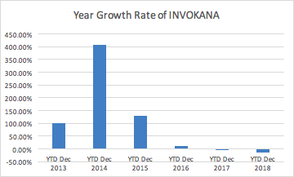

**Figure 2 (**The sale unit volume(green) v.s sale revenue(blue) of Lantus )

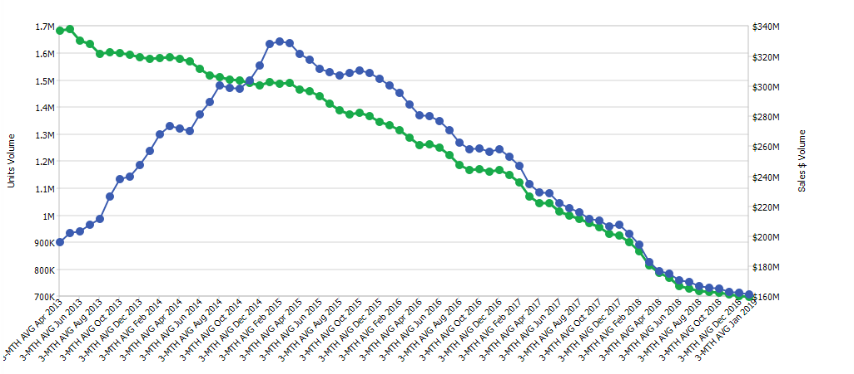

**Figure 3 (**The sale of Invokana(BLUE), Farxiga(GREEN), Jardiance(RED))

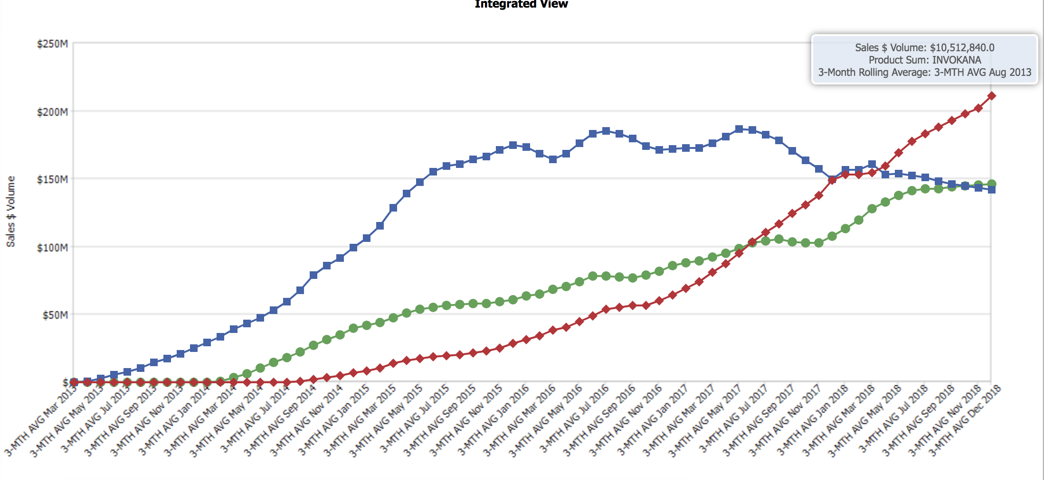

**Figure 4 (**Sale Revenues of Januvia(green),Onglyza(blue),Tradjenta(red))

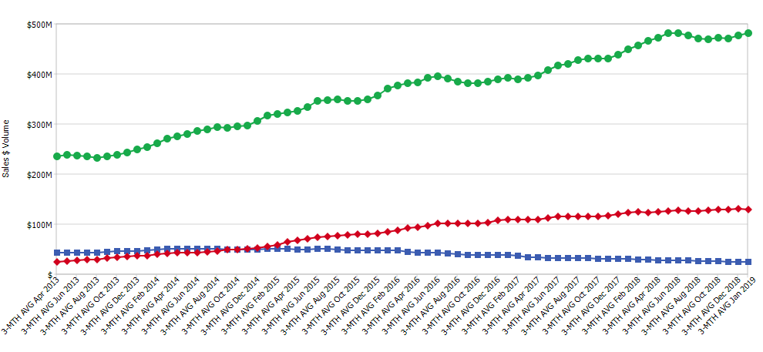

**Figure 5 (**Units sale of Januvia(green),Onglyza(blue),Tradjenta(red))

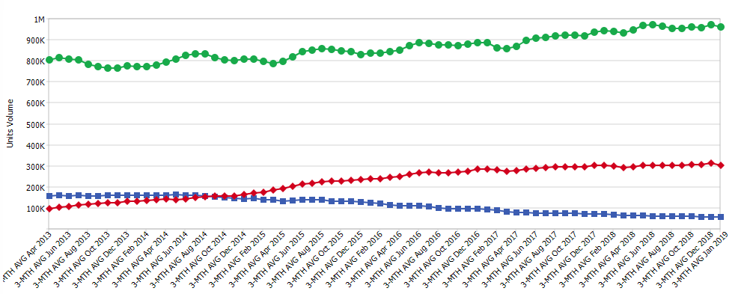

**Appendix B**

**Forecasting Sale of Invokana (Figure 1)**

Here is the forecasting sale of Invokana for next two year. The dashed line represent where we cut the data. The part after the vertical solid line is our forecasting result.

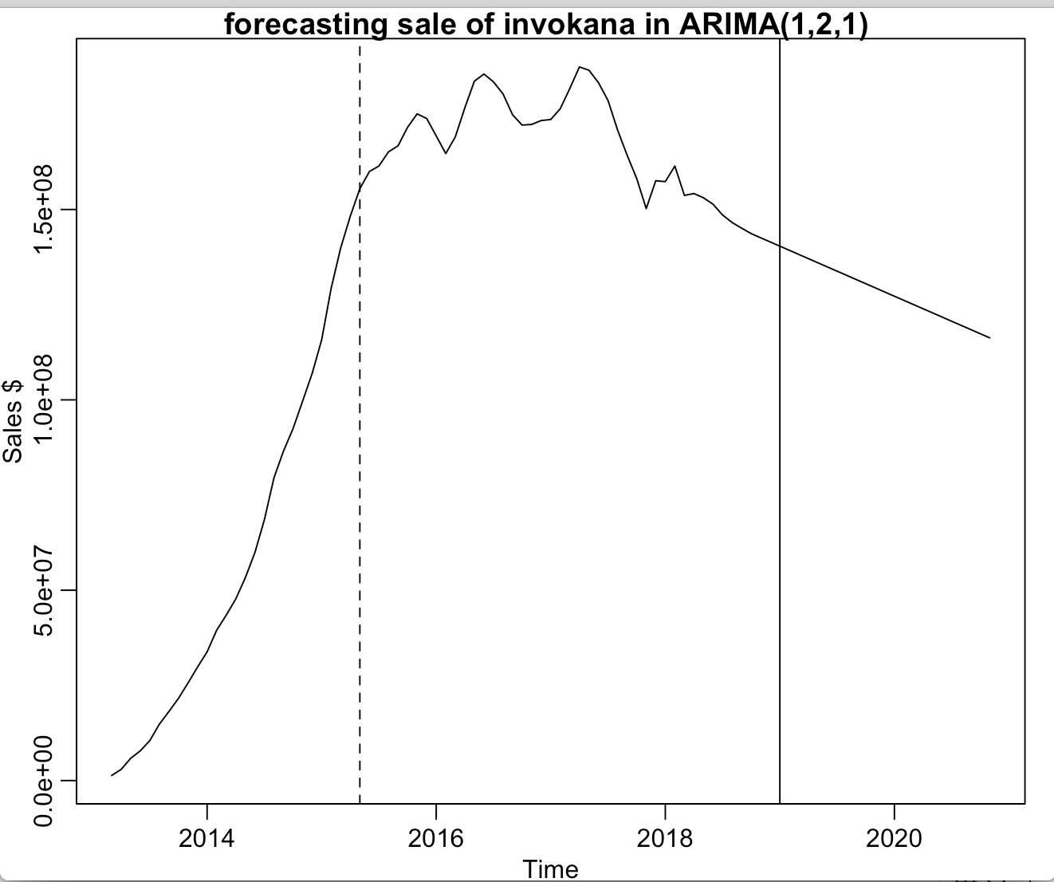

In the beginning, we tried to use the entire dataset to do the model fitting. However, the forecasting result decrease faster as the time go by, which may be affected by the beginning part where the sale increase rapidly. Thus, we only use the data after April, 2015 and do the model fitting with ARIMA(1,2,1). Moreover, we also compared the AIC of the model that with original data and the model with cutted data. The model fitted with the cutted data has lower AIC, so that is another reason why we used the cutted dataset to do the model fitting.

**The forecasting sale of Farxiga (Figure 2)**

Here is the forecasting sale of Farxiga for next two years. The dashed line represent where we cut the data.

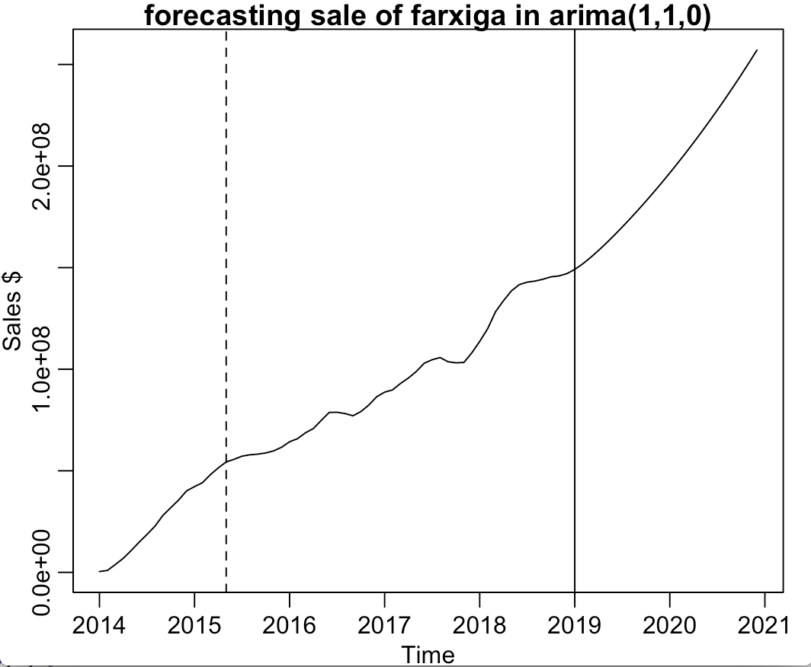

When we used the entire dataset to do the model fitting, the forecasting result would go up a little bit and start to fall down, which doesn’t look normal. Thus, we only used the dataset after April, 2015 to avoid the beginning part that increase rapidly. To conclude, we fit the dataset with log transformation and ARIMA(1,1,0).

**The forecasting sale of Jardiance (Figure 3)**

Here is the forecasting sale of Invokana for next two year. The part after the vertical solid line is our forecasting result.

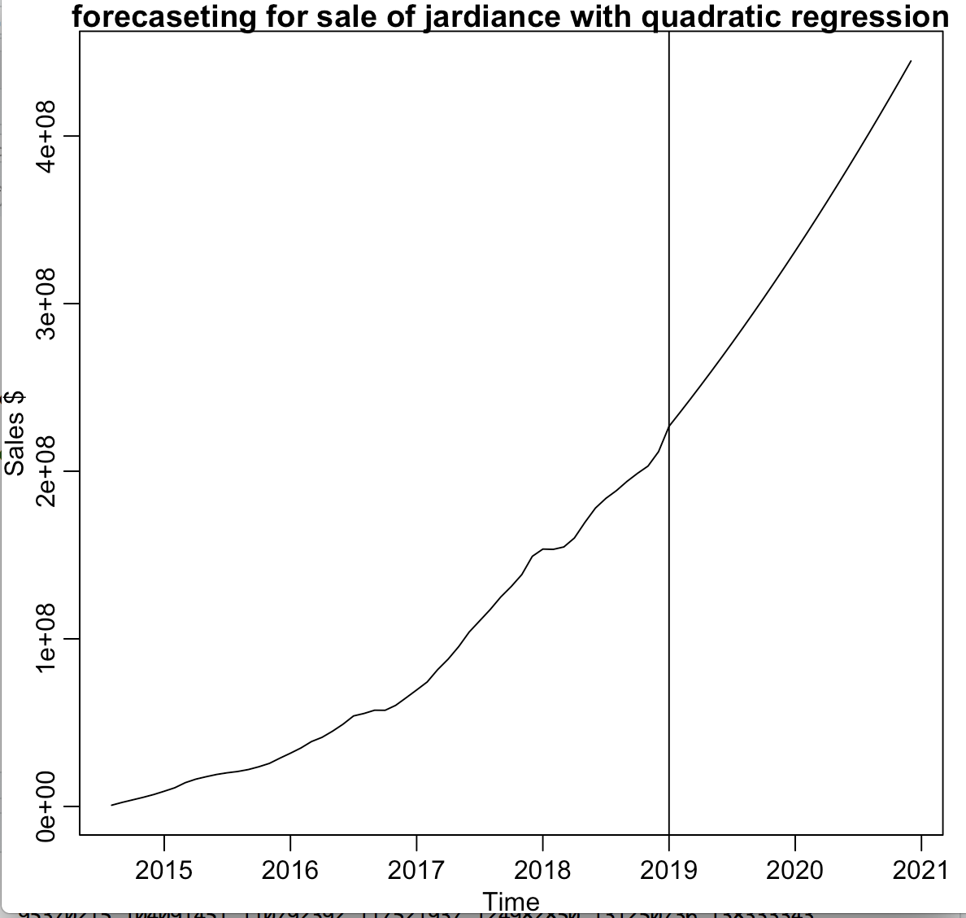

We used the quadratic regression model,

sale of Jardiance=4.045*10^13-4.017*10^10*time+9.971*10^6*time^2

to fit the dataset. Since the coefficient are all significantly different from 0 and the R-Square and adjusted R-Square are greater than 99%, this regression model fit the dataset well.

**The Forecasting Sale of Three Drugs in SGLT2 Inhibitors (Figure 4)**

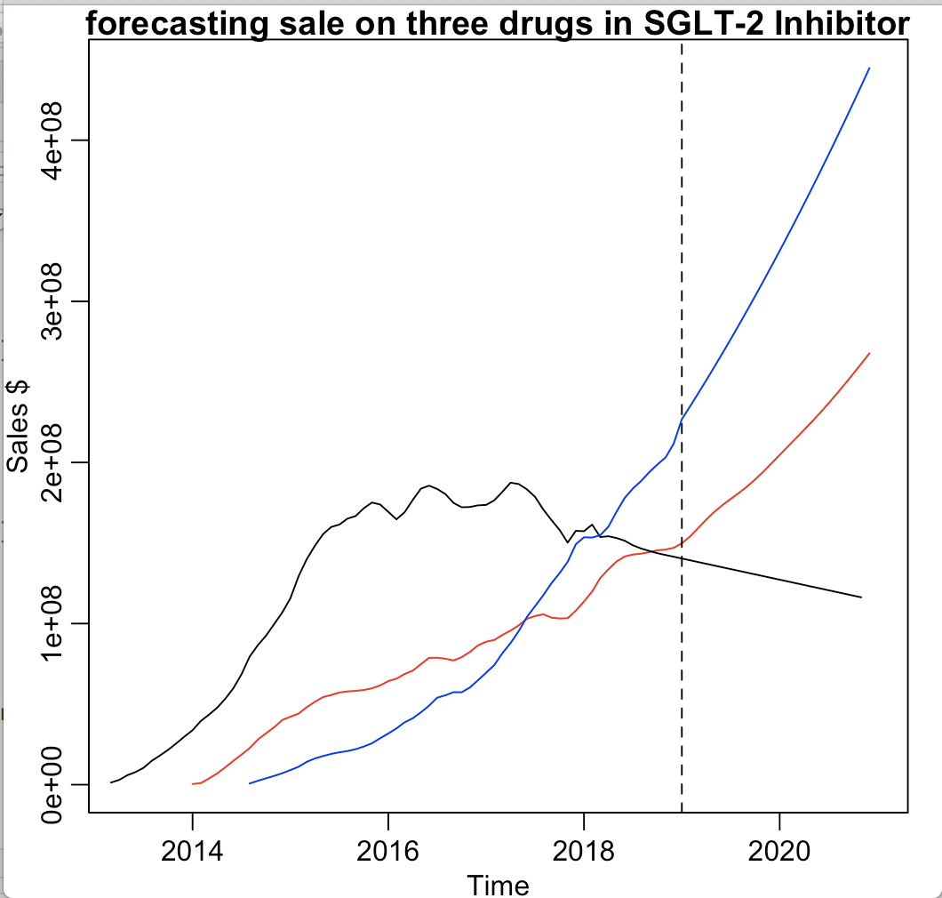

(jardiance: blue, farxiga: red, invokana: black)

**The Forecasting Sale of SGLT2 Inhibitors (Figure 5)**

Here is the forecasting sale of SGLT2 Inhibitors for next 2 years.The part after the vertical solid line is our forecasting result.

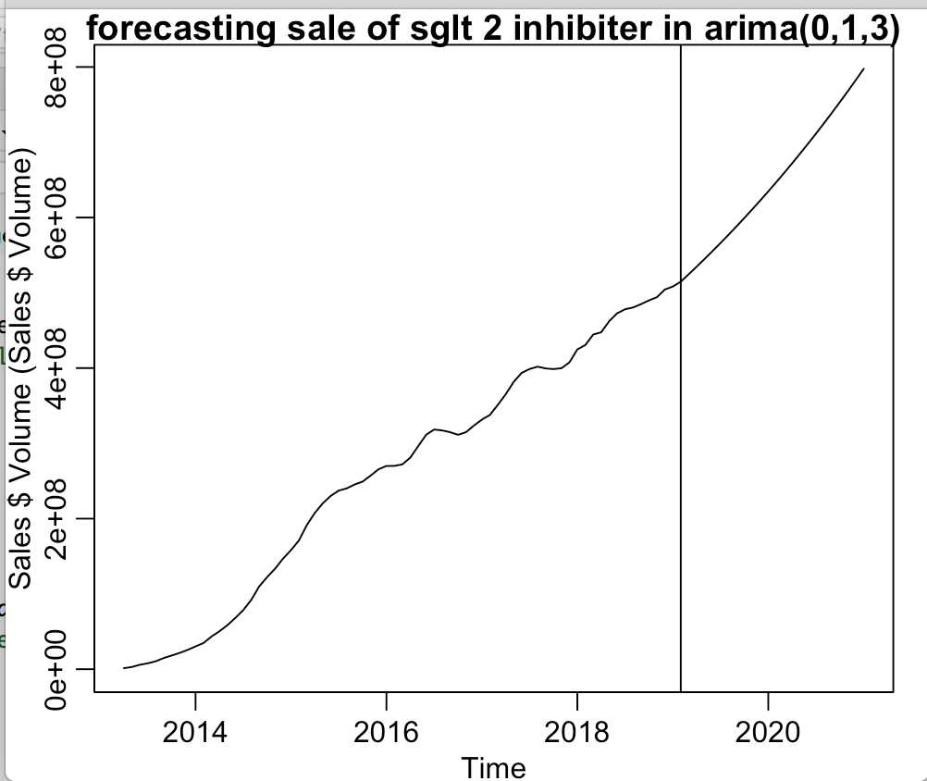

we fit dataset with ARIMA(0,1,3).

**The forecasting sale of Insulin (Figure 6)**

Here is the forecasting sale of Insulin for next 2 years.The part after the vertical solid line is our forecasting result. Also, we fit the dataset with ARIMA(4,2,0).

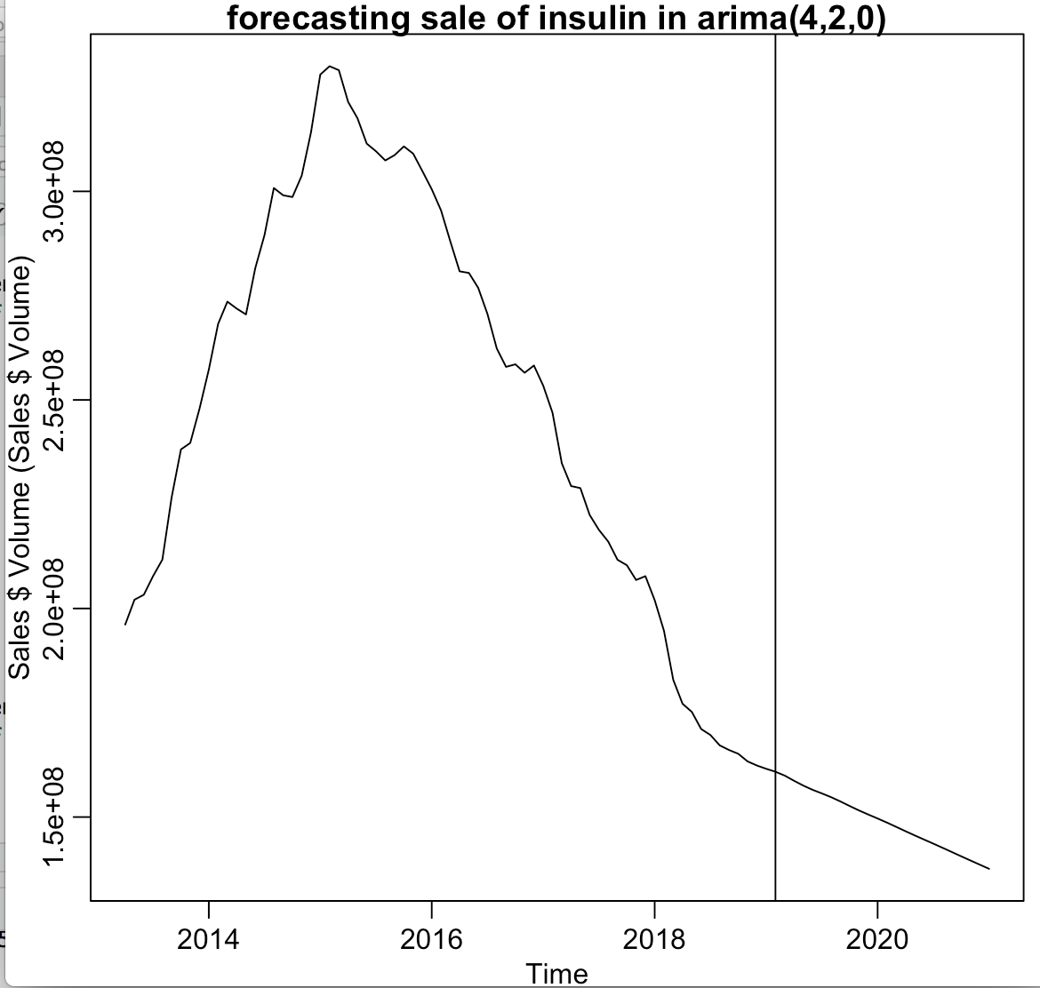

**The forecasting sale of DPP-4 Inhibitor (Figure 7)**

Here is the forecasting sale of DPP-4 Inhibitors for next 2 years.The part after the vertical solid line is our forecasting result.

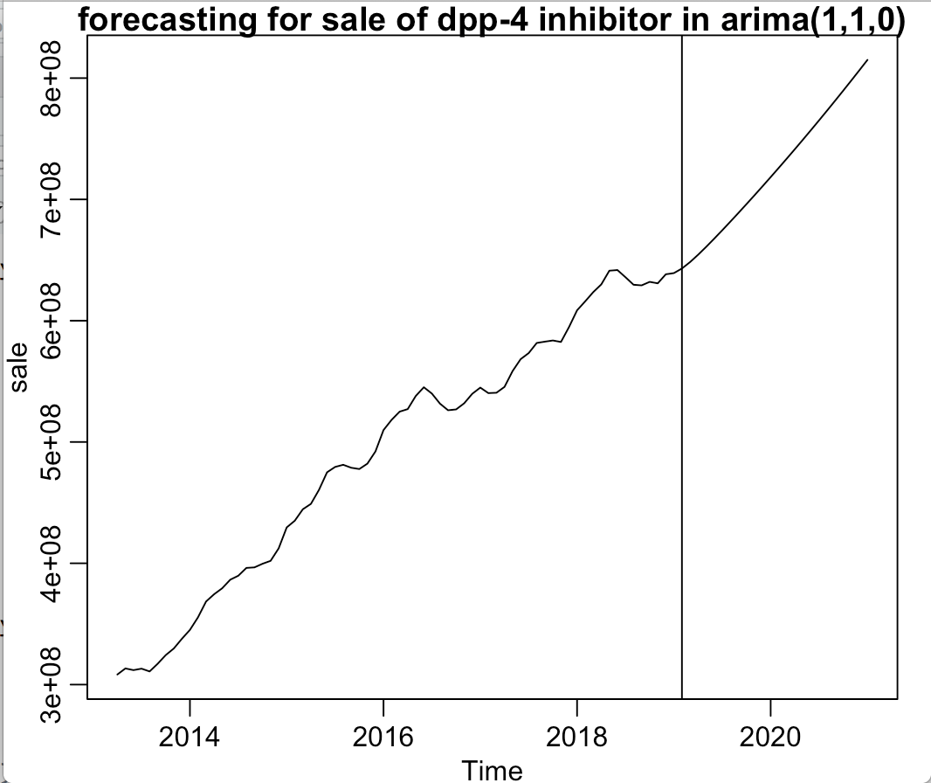

We fit the dataset with log transformation and ARIMA(1,1,0).

**The forecasting sale on three market (Figure 8)**

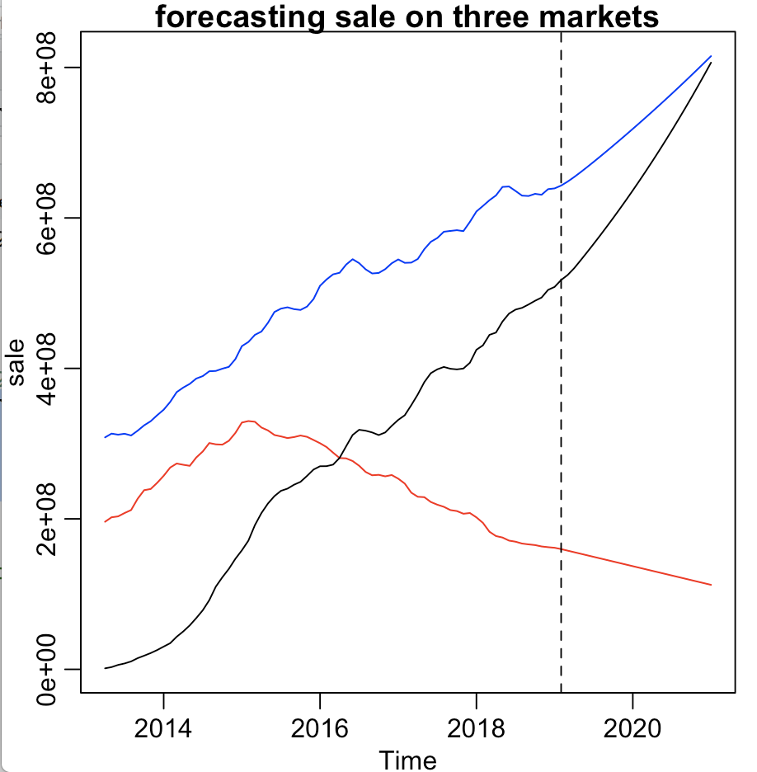

(Insulin: red SGLT-2 inhibitor: black DPP-4 inhibitor: blue)

The pros of SGLT2 inhibitor is that it can reduce the risk of heart attack and stroke. Also, it is helpful for reducing the weight. SGLT2 inhibitors don’t affect the insulin directly in our body. Instead, when the body produces the urine, the SGLT2 inhibitors prevent the kidneys from absorbing glucose back into the body. Thus it causes the higher concentration of sugar in the urine, which can lead to an increased risk of vaginal yeast infection and urinary tract infection.

DPP-4 inhibitors doesn't cause the weight gain problem and the issue of hypoglycemia, but it may cause the joint pain and pancreatitis.

Insulin is usually effective when it is used in the proper dose, but it may lead to weight gain and hypoglycemia issue.

**Appendix C**

**Competitive Advantage of Three Markets**

|  |  |  |  |
| --- | --- | --- | --- |
|  | SGLT-2 Inhibitor | DPP-4 Inhibitor | Insulin |
| Advantage | Reduce the risk of  Heart attack, stroke, and weight gain | Don’t cause weight gain and hypoglycemia | Effective if the dose is proper |
| Disadvantage | May cause vaginal yeast infection, urinary tract infection | May cause joint pain and pancreatitis | Weight gain and hypoglycemia |

**References**

<https://www.nytimes.com/2015/09/18/business/jardiance-a-diabetes-drug-is-shown-to-reduce-cardiovascular-deaths.html>

<https://www.fool.com/investing/2018/07/20/eli-lilly-scores-a-win-in-diabetes.aspx>

<https://media.mmm-online.com/documents/38/diabetes_olympics_9328.pdf>

<https://www.fool.com/investing/general/2015/03/21/this-is-why-diabetes-treatment-costs-are-soaring.aspx>

<https://www.forbes.com/sites/greatspeculations/2017/05/18/understanding-jjs-risk-from-new-fda-label-warning-for-invokana/#4537253a7c79>

<https://www.transparencymarketresearch.com/sglt2-inhibitors-market.html>

<https://www.ncbi.nlm.nih.gov/pmc/articles/PMC6028052/>

<https://www.biopharmadive.com/news/astrazeneca-cvd-real-sglt2-diabetes-farxiga/438425/>

<https://www.fiercepharma.com/sales-and-marketing/j-j-s-invokana-fends-off-new-sglt2-rivals-to-hit-278m-q1>

<https://www.cdc.gov/diabetes/pdfs/data/statistics/national-diabetes-statistics-report.pdf>

<https://onlinelibrary.wiley.com/doi/full/10.1111/dom.13294>

<https://www.diabetes.co.uk/diabetes-medication/dpp-4-inhibitors.html>